# Setup guide for Google Colab

**This is a free service that may not always be available, and requires extra steps to ensure your work is saved. Be sure to read the docs on the Colab web-site to ensure you understand the limitations of the system.**

### Accessing Colab

First of all you should sign in to you Google account if you are not signed in by default. You must do this step before opening Colab, otherwise the notebooks will not work.

Next, open a new Python 3 Notebook or open an exercise notebook from the github repository (when available).

### 2. Configuring your notebook instance

You should see your notebook displayed now. Before running anything, you need to tell Colab that you are interested in using a GPU. You can do this by clicking on the ‘Runtime’ tab and selecting ‘Change runtime type’. A pop-up window will open up with a drop-down menu. Select ‘GPU’ from the menu and click ‘Save’.

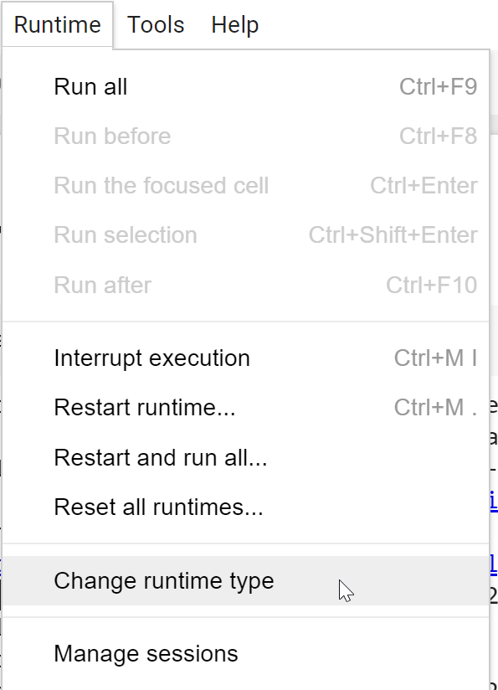

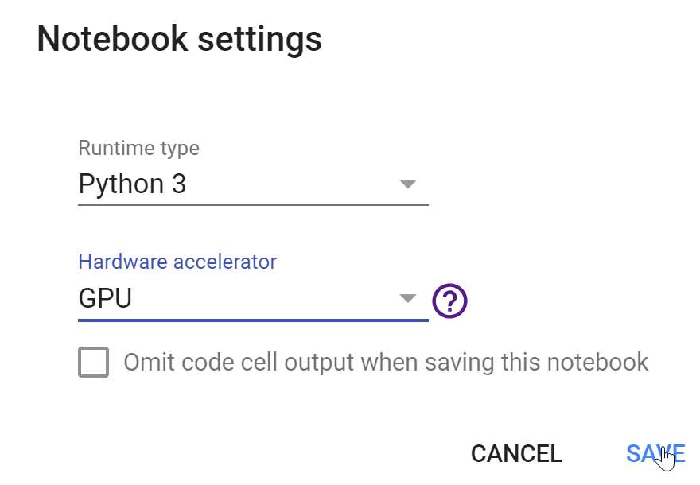

If you run a script which creates/ downloads files, the files will NOT persist after the allocated instance is shutdown. To save files, you need to permit your Colaboratory instance to read and write files to your Google Drive. Add the following code snippet at the beginning of every notebook.

from google.colab import drive

drive**.**mount('/content/gdrive', force_remount**=**True)

root_dir **=** "/content/gdrive/My Drive/"

base_dir **=** root_dir **+** 'DKFZ_Deep_Learning'

Now, you may access your Google Drive as a file sytem using standard python commands to both read and write files.

Before you start using your notebook, you need to install the necessary packages. You can do this by creating a code cell, and running:

**!**curl -s https://course.fast.ai/setup/colab | bash

When you run the first cell, you may face a pop-up saying ‘Warning: This notebook was not authored by Google’; you should leave the default tick in the ‘Reset all runtimes before running’ check box and click on ‘Run Anyway’.

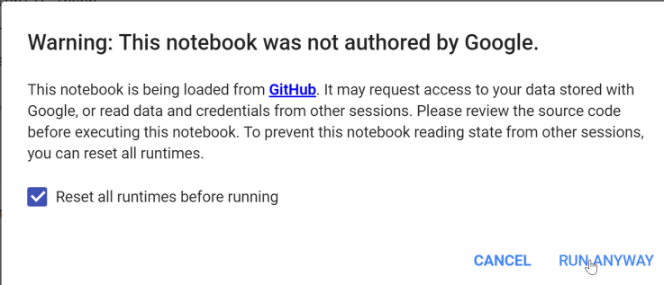

**3. Saving your notebook**

If you opened a notebook from Github, you will need to save your work to Google Drive. You can do this by clicking on ‘File’ and then ‘Save’. You should see a pop-up with the following message:

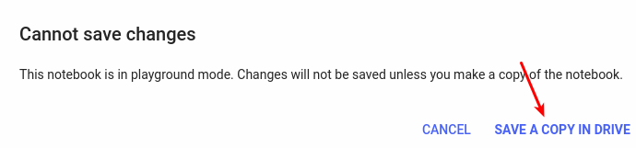

Click on ‘SAVE A COPY IN DRIVE’. This will open up a new tab with the same file, only this time located in your Drive. If you want to continue working after saving, use the file in the new tab. Your notebook will be saved in a folder called Colab Notebooks in your Google Drive by default.